**Lingyi Zhao**

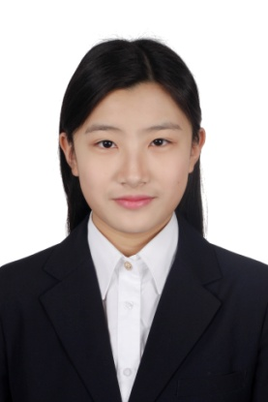Contact

(+86) 18811015390

cicizhao@thsi.com.cn

Education

**Grades 7—9** Tsinghua University Attached Middle School

**Grades 10—12** Tsinghua University Attached International High

School ( THIS )

**2017.7-2017.8** Ashville High School Summer Program in North Carolina

Academic Highlights

* AP courses taken: Physics, Calculus, Human Geography.
* SAT score 1460(730,730)
* American Ashville High School Summer program- 5 courses with a focus on civil rights: U.S History, Civil Rights, Research, Creative Writing, Composition. Obtained “A’s” in all of these courses.
* Current overall GPA: 3.4-3.5

Interests & volunteering

**Performing Arts**

* Traditional Chinese style dance, Hip hop, Latin and tap dance.
* Dance group member of Tsinghua Attached Primary School, Middle School and High School, respectively.
* I have always enjoyed singing and expressing creativity through art and painting.
* Former member of the Galaxy Club, a very prestigious performing group for kids, this included singing, dancing and painting. I got to perform all over China and even did short tours in Australia and Taiwan.
* Performing painter in the 2008 Beijing Olympics Opening Ceremony.
* Performing dancer for the CCTV Spring Festival Show, one of the most televised and watched shows in all of China as it marks the start of the year.
* Met current president of China Xi Jinping and former Vice President of the U.S. Joe Biden at a national dance event.

**Master of Ceremonies**

* Hosted a wide range of public events all over China (graduation ceremonies, music and art events, competitions, etc.) I have been hosting for over 10 years now.
* My latest event was the Teenager National Art Competition 2018 held in Ningbo, China.

**Volunteer**

* Education USA College Fair

An annual event where a wide range of American colleges and universities talk to prospective students at our school. My responsibilities included welcoming parents and student, helping them register and find potential universities of interest.

* International Energy Competition for the Future 2018 and Future Power Electronics Workshop held in Tsinghua University.

Two national events with a focus on electrical engineering, during this event I was in charge of registering all guests and providing guidance for the venue, I got to meet and interact with some of China’s brightest students and other foreign students as well.

* Sunshine Village Foster House

Volunteered at a foster home located in the suburbs of Beijing, the great majority of kids here had their parents in jail and unable to provide for them. I would play and spend time with these kids to make their day a little brighter; I also donated canned food and clothes.

Clubs and programs

**Lotus Dance Club**

* Founded and promoted a new dance club at my high school, I encouraged girls who had little to no previous dance experience to join.
* My responsibilities included planning rehearsals, choreography, costumes, booking events etc.

**English Club**

* Member of the English club where we had weekly meetings and discussed currents and pop culture in English.
* Played vocab games to improve my lexicon, and read a wide range of books.

**Global Social Leaders Catalyst Program**

* One week before the start of the regular academic high school year, teachers from the U.K. come to our school and provide several lectures and presentations to inspire and prepare students for the upcoming year. Topics include things like self-control, time management, study tips, etc. This program has always put me in the right mindset before the start of each high school year.

Award and Honor